***Day 04: Building Dynamic Frontend Components for Marketplace***

***Made By : SYED SALMAN ALI***

***ROLL NO. 979***

Key Components to build:

1. Product Listing Component:

Code snippet: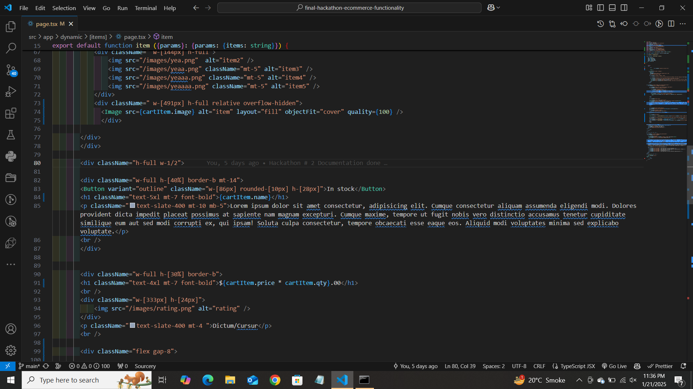Output: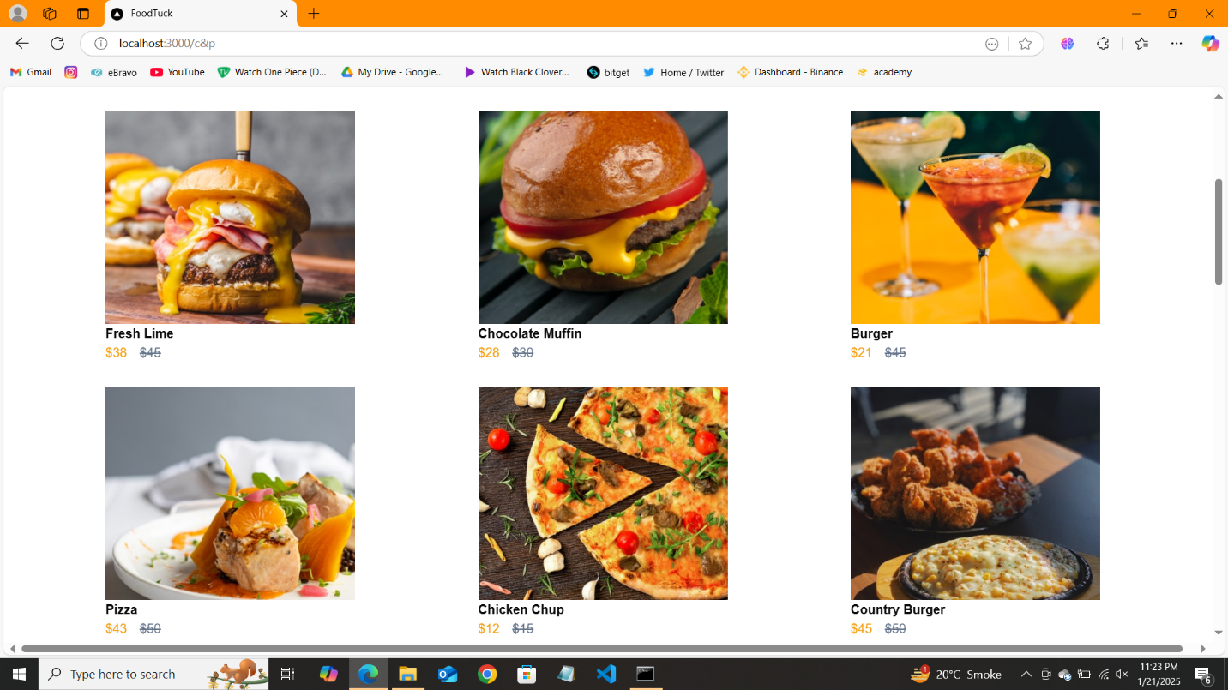

1. Product Detail Component

Code snippet:



Output:

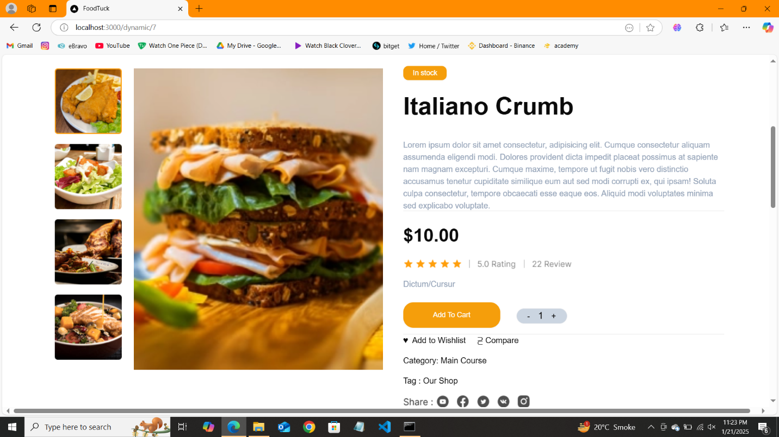

1. Category Component

Code snippet:

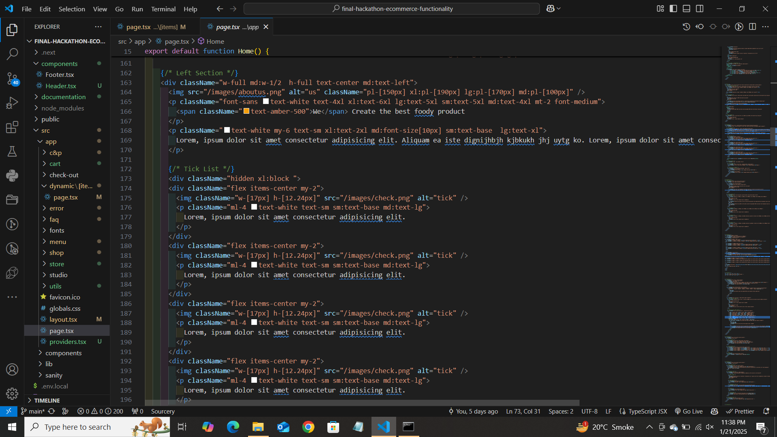

Output:

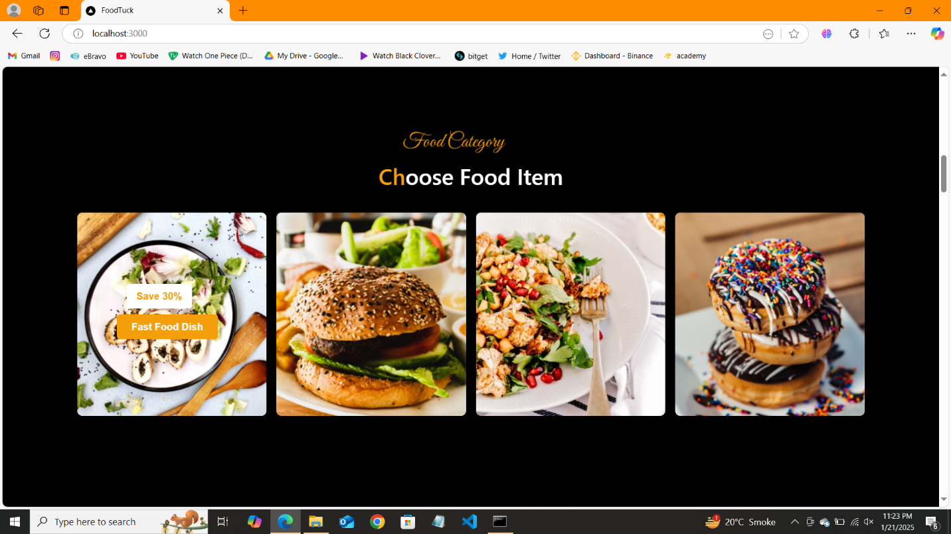

1. Cart:

Code snippet:

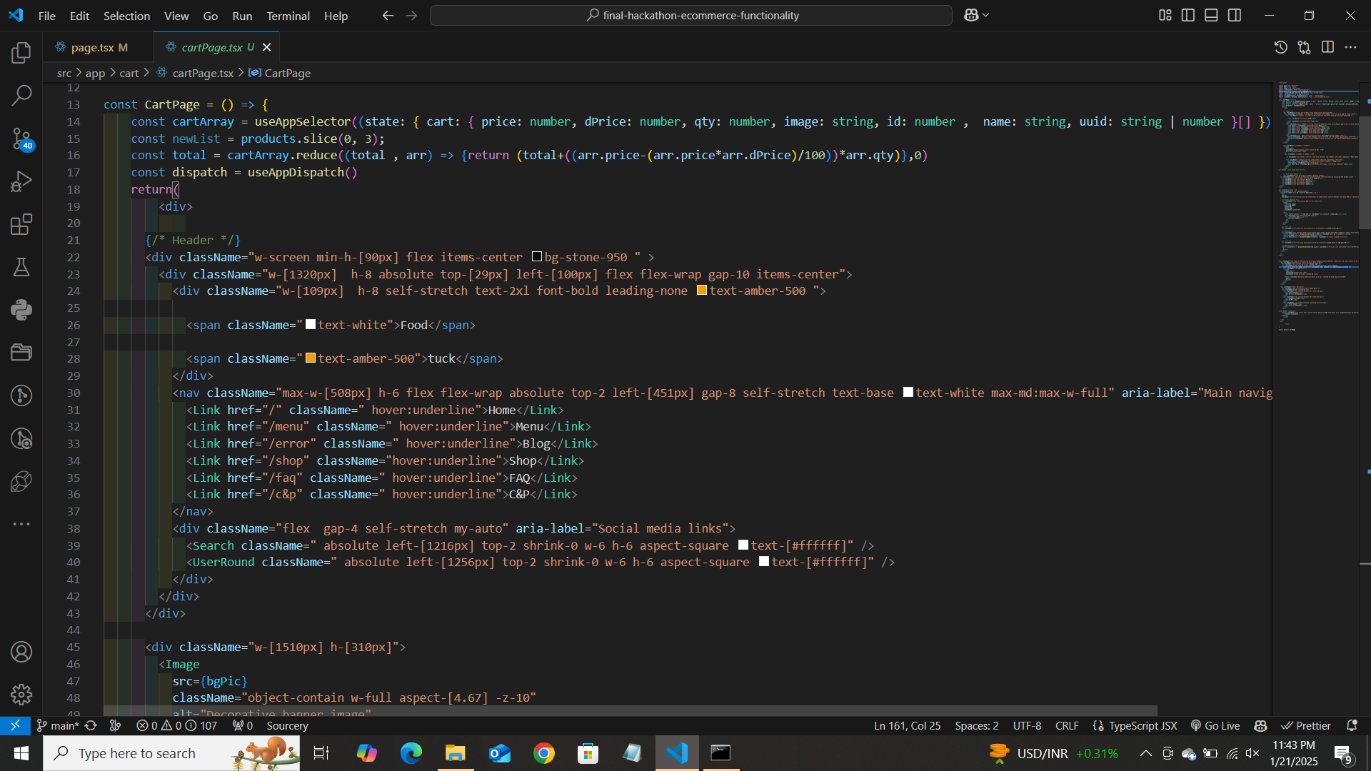

Output:

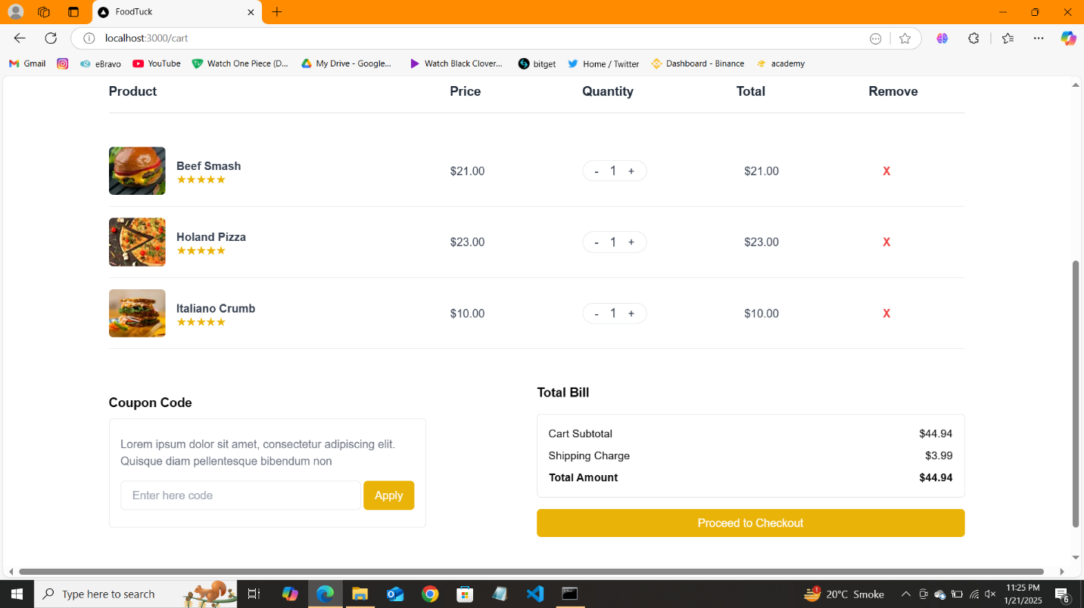

1. Checkout :

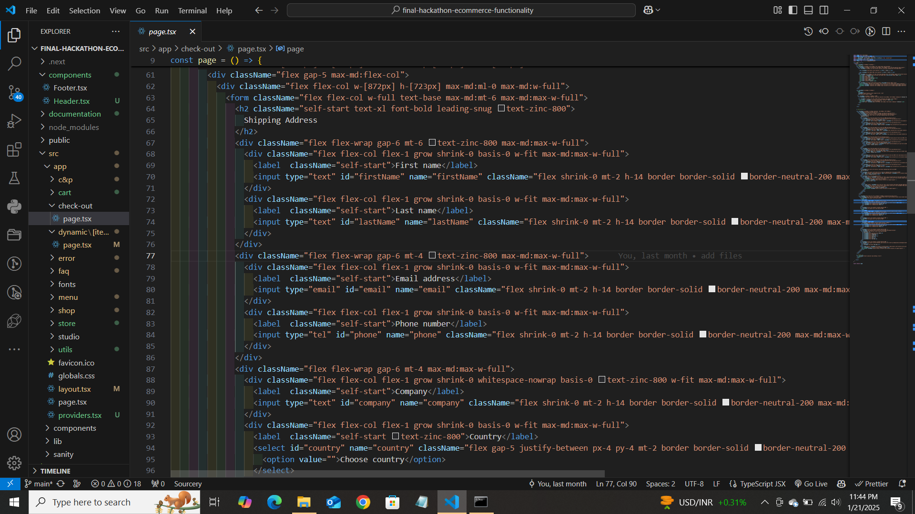

Output:

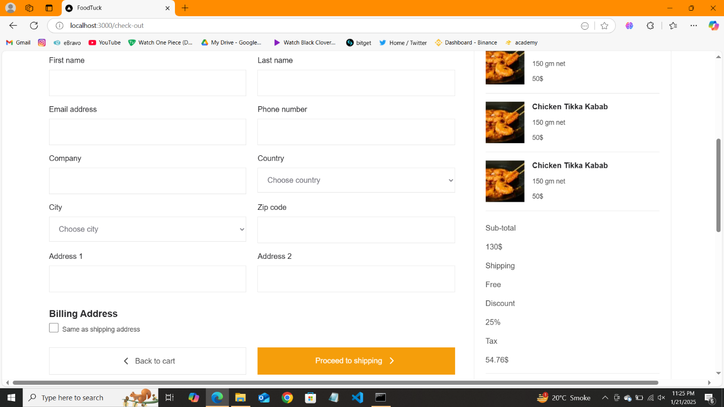

1. Filter Panel =

Code snippet:

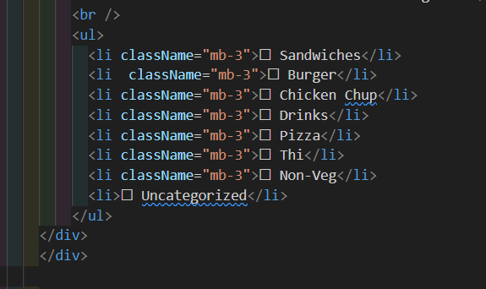

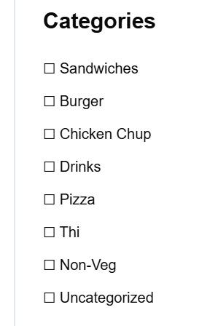

1. Header:

Code snippet:

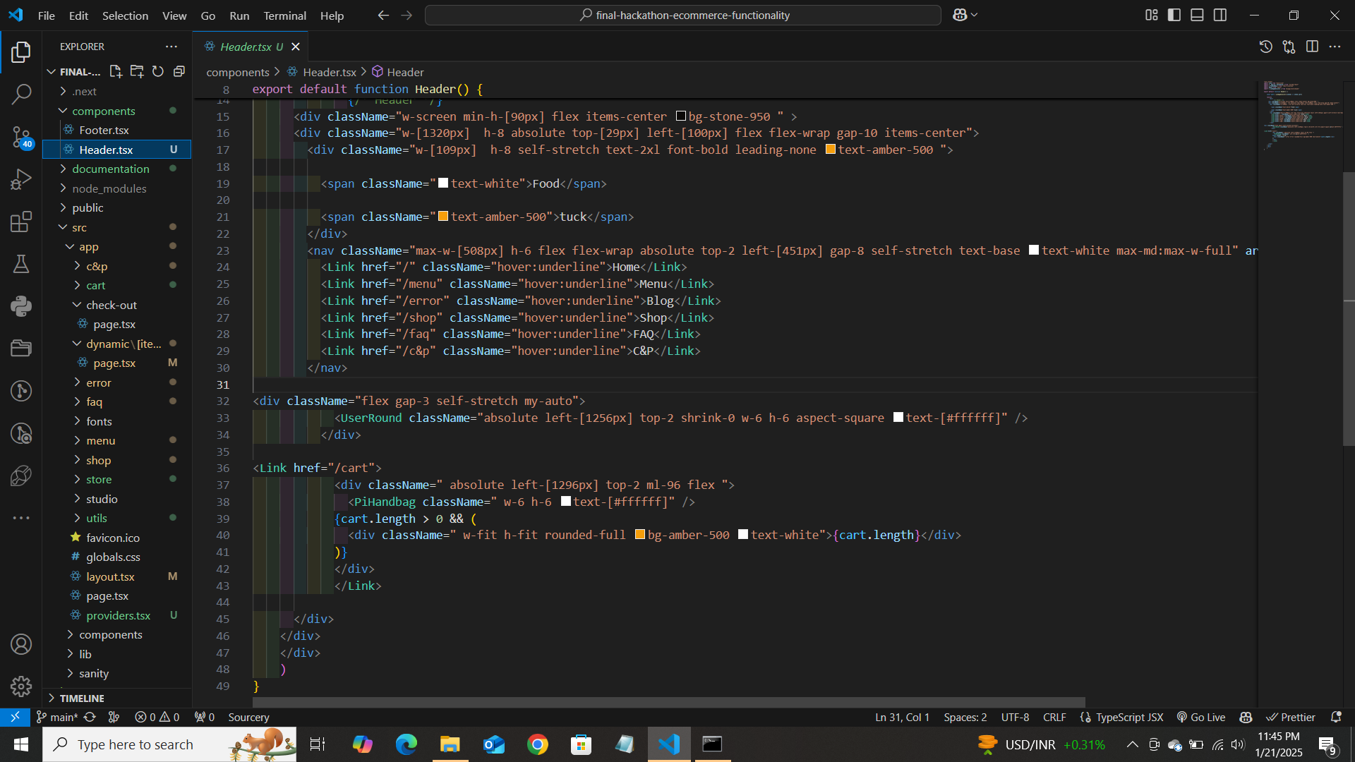

Output:



1. Footer:

Code snippet:

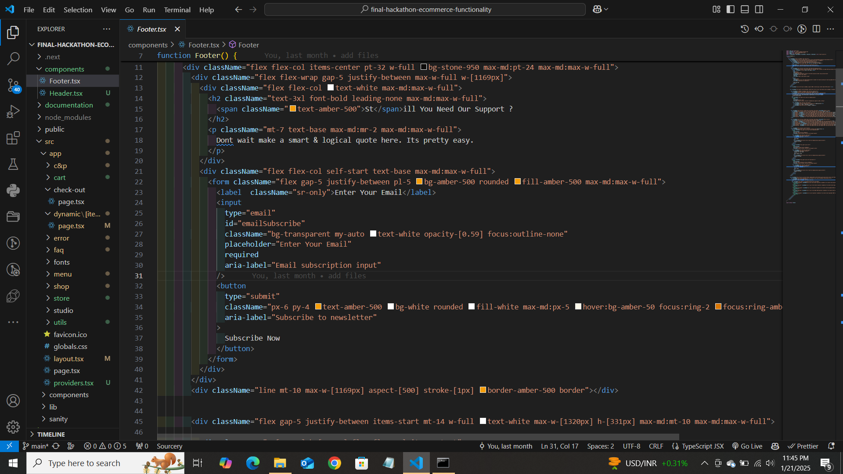

Output;

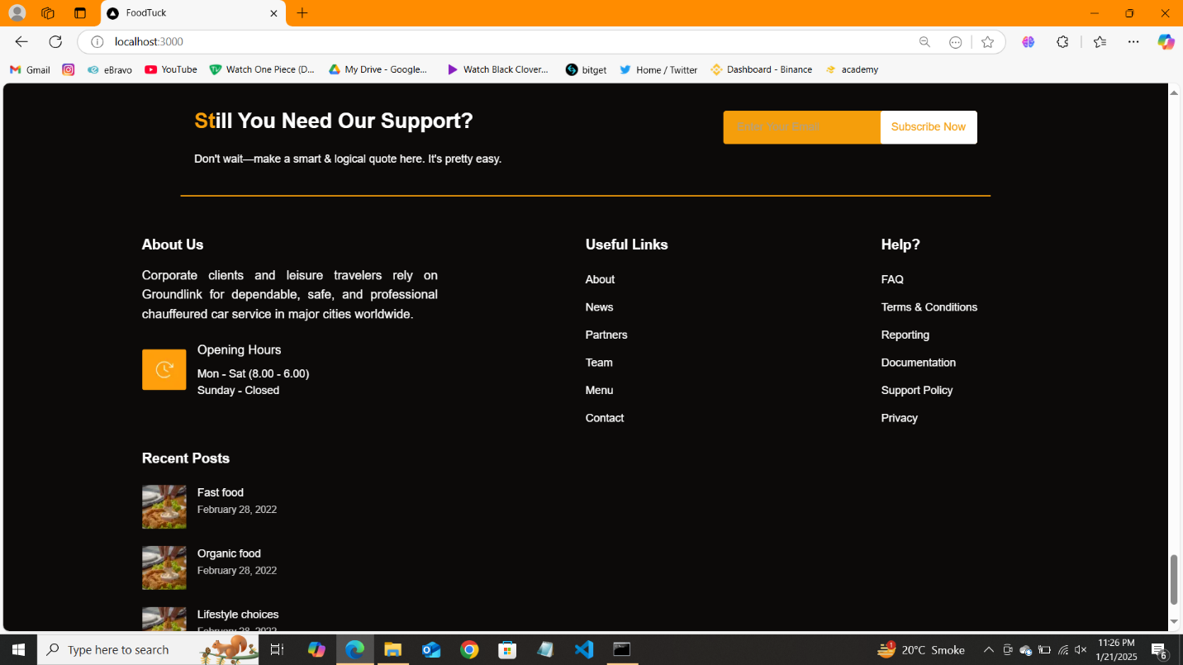

1. FAQ & Help =

Code snippet:

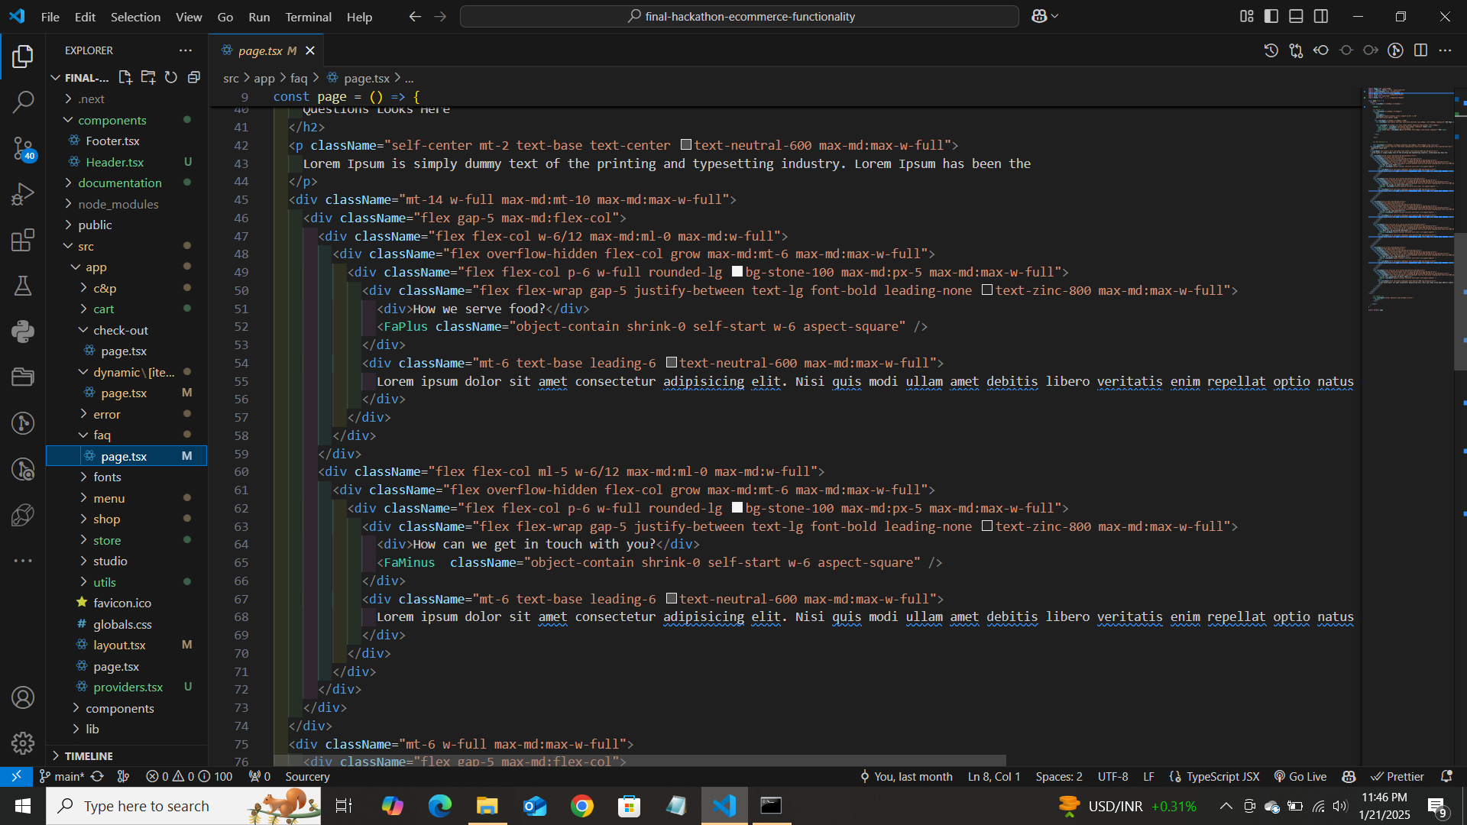

Output:

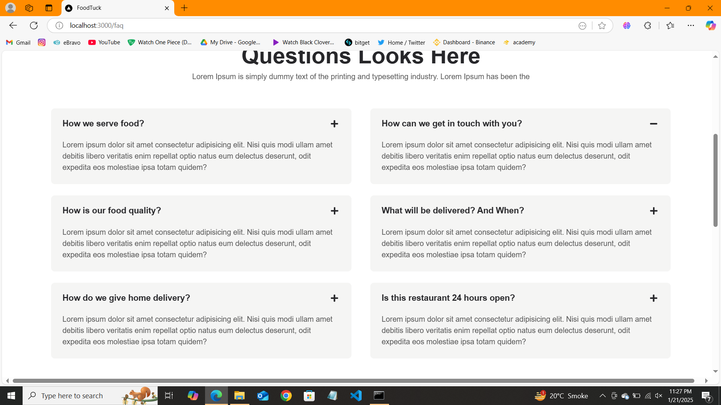

1. Social Links :

Code snippet=

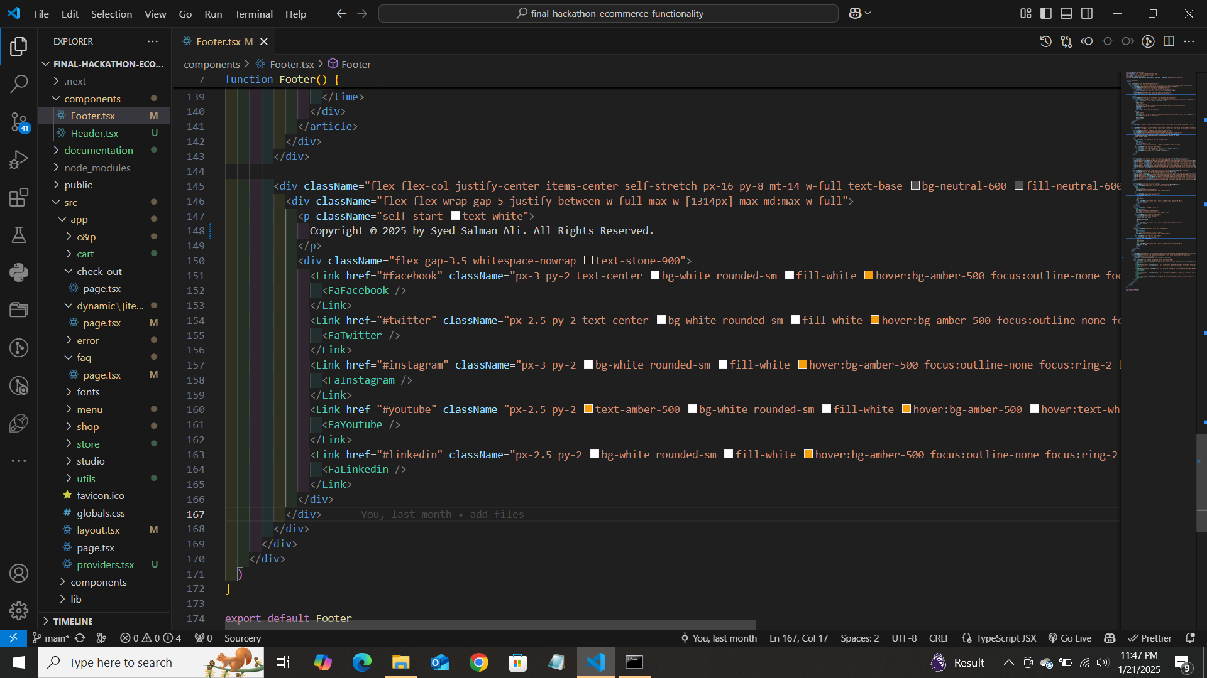

Output:



1. Search Bar:

See the video outside named “search bar”

Self-Validation Checklist:

Frontend Component Development: ✔

Styling and Responsiveness: ✔

Code Quality: ✔ Documentation and Submission: ✔